**Pivot Viewer Component**

This component will be an added perspective on the data to give the use a visual representation of the data and allow them to see the information at a glance and the with the addition of rich filtering allow them to drill down into the data to get more information and then do specific actions on it accordingly.

**Use Context**

| **Question** | **Assumption** |
| --- | --- |
| What is the Pivot Viewer Component? | * Moving through large sets of data * Exploring hidden relationships * Filtering data to find items in large sets of data |
| What function is supposed to be provided by the Pivot Viewer component? | * Allow users Filter using a rich filter component * Allow users to view large sets of data * Allow users to compare various data alongside on another. |
| What are the aims? | Allow the user to compare data and easily make decisions and take action |
| Who is the comp intended for? | The component will be used by majority of the OK users. Users can use it to quickly filter through the data to get to their goals quick and make fast decisions to save time and take quick action. |

**Functions needed.**

**Query Builder**

The Query Builder is a vital component in this case as the user must pre-sort or pre-filter the data before viewing the items in **Pivot Viewer**.

**Properties Panel**

A user will be able to filter the data using the standard properties panel. The PP will allow the user to set the columns to show the data differently it will also give the user the ability to add row sorting to give an even more thorough and detailed view of the data.

**Filtering**

The filtering is based on a rich filtering component that will allow the user to easily filter the data in a way that makes sense to the user but at the same time giving

him or her all the info they need

**Views**

The default view will always be the dashboard (Grid/table), from there you can go to the **Pivot Viewer** that gives you the following views:

1. Grid view – this is an unsorted list but with filtering you can quickly see the groupings come alive.

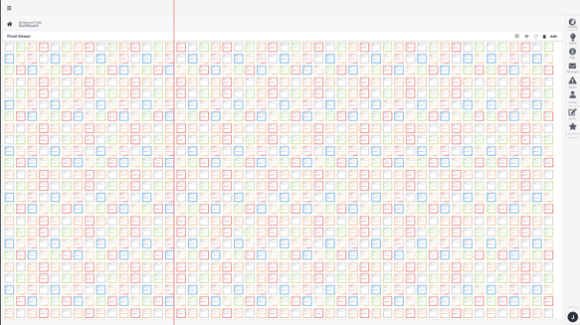

1. Graph view – This puts in a graph look and feel an makes it easy to see the amounts as per the details

­

**Zoom**

The zoom will allow the user to see the trend from far away and the be able to zoom in closer to get more detail and information, therefore we will have zoom levels. Each level will bring different information to the front until you get to the final level that will give you all the information. In our case we will be using a 4Level zoom:

**Level 1*:* Zero**

This is the start page that like we said above will allow the user to see the trend. This will also be color based and each color will represent an specific filter option.

**Level 2: Far away**

This will add some detail to the card displaying on the screen this will allow the user to see sum information. This will be customizable to allow users to set the info on this card as they desire.

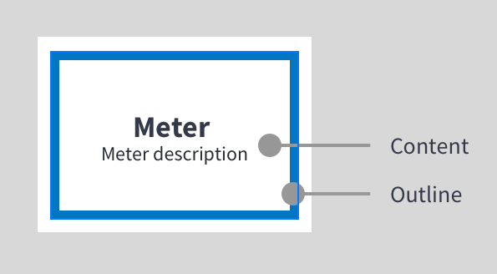­

**Level 3: Medium Distance**

This will add some detail to the card displaying on the screen this will allow the user to see a small summary and get an idea of what the data is telling

him/her. This will be customizable to allow users to set the info on this card as they desire.

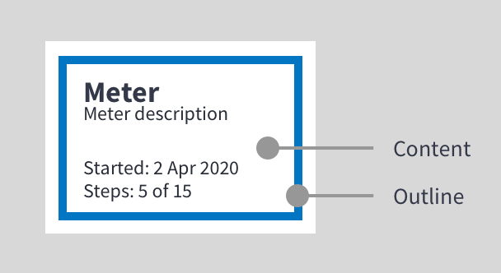

**Level 4: Up Close**

This will give the user a preview modal, the user will also be able to click on this view and they will be directed to the edit view to see more information. ­

